Agenda Item : 2/03

= application site



Street Record, Elizabeth Gardens, Stanmore | P/2408/20
Location Plan

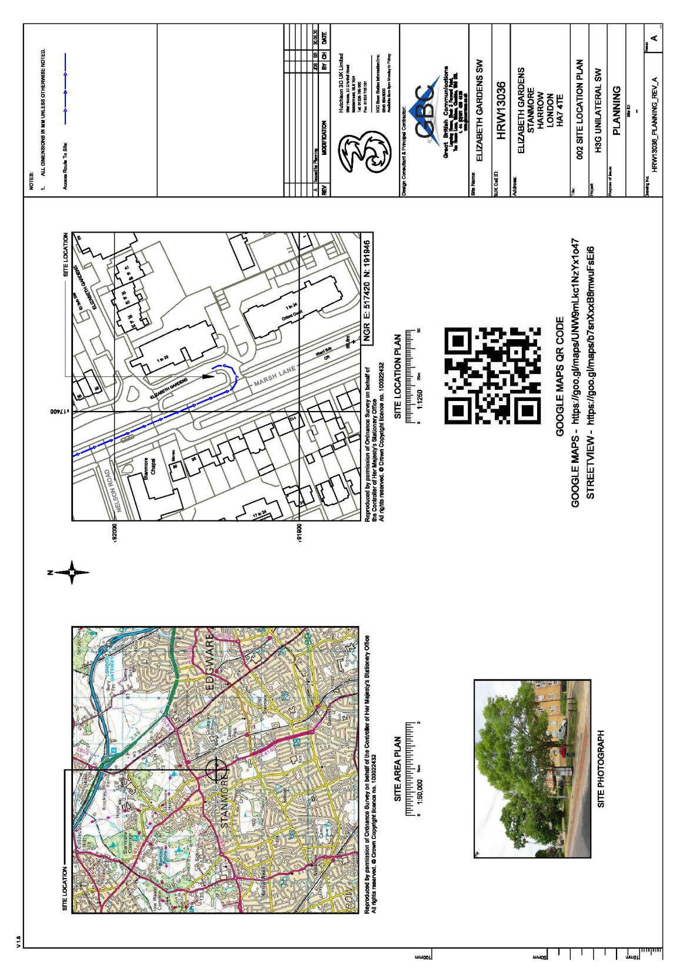

LONDON BOROUGH OF HARROW

PLANNING COMMITTEE

2nd September 2020

APPLICATION NUMBER: | P/2408/20
VALID DATE: | 5th AUGUST 2020
LOCATION: | VERGE FRONTING 1-28 ELIZABETH GARDENS ADJACENT TO INTERSECTION WITH MARSH LANE, STANMORE
WARD: | CANONS
POSTCODE: | N/A
APPLICANT: | Hutchison 3G UK Limited
AGENT: | Chris Weir
CASE OFFICER: | WILL HOSSACK
EXPIRY DATE: | 7th SEPTEMBER 2020

PROPOSAL

Prior Approval Of Details And Siting For Installation Of 20M High Phase 8 Monopole With Wraparound Cabinet At Base; Three Equipment Cabinets And Associated Works For 5G Network
RECOMMENDATION

The Planning Committee is asked to:

1) Grant prior approval of details of siting and appearance for the development described in the application and submitted plans.

REASON FOR THE RECOMMENDATION

The proposed impact of the proposal, despite the height of the 20m high monopole, would not be considered to be of significant detriment to the character appearance of the area nor residential amenities. This is due to the existing local context provided by its siting including the partial screening of trees and street furniture, and the presence of existing telecommunications equipment in close proximity to the application site. The proposal therefore accords with the Harrow Development Management Policies Local Plan as its siting minimises its impact on the area, whilst providing a significant public benefit. The demonstration of the unsuitability of alternative site also adds weight, in accordance with the NPPF, to the proposal. Having regard to the strong weight attached to telecommunications development outlined in the NPPF, it is considered on balance the proposal would not result in unreasonable harmful impacts on the character and appearance of the area. Accordingly, prior approval is required and is recommended for grant

INFORMATION

This application is reported to Planning Committee at the request of a nominated member in the public interest. The application is therefore referred to the Planning Committee as it does not fall within any of the provisions set out at paragraphs 1(a)-1(h) of the Scheme of Delegation dated 12th December 2018.

Statutory Return Type: | E29
Council Interest:  Net additional Floorspace: | Adopted Highway  N/A
GLA Community Infrastructure Levy (CIL) Contribution (provisional): | N/A
Local CIL requirement: | N/A

HUMAN RIGHTS ACT

The provisions of the Human Rights Act 1998 have been taken into account in the processing of the application and the preparation of this report.

EQUALITIES

In determining this planning application the Council has regard to its equalities obligations including its obligations under section 149 of the Equality Act 2010.

For the purposes of this application there are no adverse equalities issues.

S17 CRIME & DISORDER ACT

Policies 7.3.B and 7.13.B of The London Plan and Policy DM1 of the Development Management Polices Local Plan require all new developments to have regard to safety and the measures to reduce crime in the design of development proposal. It is considered that the development does not adversely affect crime risk.

- SITE DESCRIPTION

1.2 The subject site comprises a traffic island separating Marsh Lane (A4140) and Elizabeth Gardens. The traffic island is adopted highways land.

1.3 The traffic island contains a deep grass verge and contains three trees. Traffic islands are a recurring feature in the immediate locality (when heading north-west along the A4140). A three storey block of flats, no’s 1 to 28 Elizabeth Gardens is sited to the north east of the island.

1.4 The traffic island which pertains to the subject application is adjacent to a public footpath and is also adjacent to a bus stop.

1.5 The adjacent traffic island (sited to the north-west) contains existing telecommunications equipment currently operated by a different telecoms operator.

- PROPOSAL

2.1 The proposal seeks to install a 20m high phase 8 monopole with wraparound cabinet at base; three equipment cabinet and associated works for 5G network.

- RELEVANT PLANNING HISTORY

  - There is no relevant planning history relating to the application site

- CONSULTATION

4.1 A total of 300 consultation letters were sent to neighbouring properties regarding this application.

4.3 The statutory public consultation period expires on 2nd September 2020 and 4 objections were received and are summarised below. Any additional comments submitted after the agenda of the Planning Committee is published will be reported to the Planning Committee in the addendum.

Summary of Comments

Character and appearance / Residential Amenities
Proximity to local residences and nursing home; Alternative site should be sought;
Impact of siting behind trees and within the grass verge would eclipse the tree line and damage to the detriment of the area; Existing telecommunications equipment in the locality is already a detriment to the area erection of further equipment will change character of the street; Excessive height of the proposal;

Officer response: The proposal has provided documentation which detail the inappropriate nature of other sites in the locality. It is considered the proposed siting of the telecommunications mast would be the most appropriate of the all potential locations due to the screening offered by surrounding trees and the established presence of the existing telecommunications equipment in close proximity. Although the height of the telecommunications would eclipse the tree line, the 20m height of the proposal is the minimum height required to facilitate the required 5G services. It is considered the limited visual intrusion this causes would be significantly outweighed by the public benefit of 5G provision in the area and its siting is in an area considered to cause the least amount of harm to the character and appearance of the locality.

Other issues:
Health Impacts of 5G; Total Health Impacts are still to be ascertained

Officer response: The National Planning Policy Framework (2019) states that Local Planning Authorities should limit their assessment of communication infrastructure to planning grounds only, explicitly they should not set health safeguards different from the International Commission guidelines for public exposure. The NPPF further states that applications for electronic communications development (including applications for prior approval under the General Permitted Development Order) should be supported when a statement is provided that self-certified that, when operational International Commission guidelines will be met. The application has submitted a statement declaring conformity with the International Commission On Non-ionising Radiation Protection (ICNIRP) guidelines once operational. It is therefore considered within the scope of the planning process the proposal has provided the relevant declaration to not be considered to have an adverse effect on health.

4.4 Statutory and Non Statutory Consultation

4.5 A summary of the consultation responses received along with the Officer comments are set out in the Table below.

Consultee and Summary of Comments

LBH Highways
The proposal would not cause any loss of visibility for vehicular users of the highway and ergo would not raise any highway safety concerns.

5.0 POLICIES

5.1 This application has been made under Part 16 of Schedule 2, of the Town and Country Planning (General Permitted Development) (England) Order 2015, as amended. This requires the developer, inter alia, to submit to the local planning authority for prior approval as to the siting and appearance of the equipment.

5.2 The Government has issued the National Planning Policy Framework [NPPF 2019] sets out the Government’s planning policies for England and how these should be applied, and is a material consideration in the determination of this application.

5.3 In this instance, the Development Plan comprises The London Plan 2016 [LP] and the Local Development Framework [LDF]. The LDF comprises The Harrow Core Strategy 2012 [CS], Harrow and Wealdstone Area Action Plan 2013 [AAP], the Development Management Policies Local Plan 2013 [DMP], the Site Allocations Local Plan [SALP] 2013 and Harrow Local Area Map 2013 [LAP].

5.4 While this application has been principally considered against the adopted London Plan (2016) policies, some regard has also been given to relevant policies in the Draft London Plan (2019), as this will eventually replace the current London Plan (2016) when adopted and forms part of the development plan for the Borough.

5.5 The document was originally published in draft form in December 2017 and subject to Examination in Public (EiP) with the Panel’s report published in October 2019. The Mayor of London has considered these recommendations, and has either accepted them or where not, provided justification as to why accepting them would not be appropriate. The Mayor has now submitted to the Secretary of State an ‘Intend to Publish’ version of The Plan. It is for the Secretary of State to determine whether he agrees with the revised Plan and it ought to be published in that form.

6.0 ASSESSMENT

6.1.1 The main issues are:

Telecommunications Development
Compliance with ICNIRP guidance
Character of the Area and Visual Amenity
Highway Safety

6.2 Telecommunications Development

The relevant policies and legislation are:
  - The National Planning Policy Framework (2019)
  - Harrow Development Management Policies (2013): DM49
  - The Town and Country Planning (General Permitted Development) (England) Order 2015 (as amended) Schedule 2, Part 16, Class A.

6.2.1 The public benefit of the proposal would be enabling 5G coverage to an area identified as a ‘coverage hole’ by the operator. This accords with policy guidance in the NPPF which highlights the importance of high quality communications infrastructure, both for sustainable economic growth and to enhance local community facilities and services. In justifying a location for a new mast or base station, the NPPF states that applicants should provide evidence that they have explored the possibility of erecting antennas on an existing building, mast or other structure. The subject application has provided and complied with all the necessary prerequisites pertaining to the prior approval process (including serving notice to the Highway Authority, who own the application site land) and as such subject to prior approval in regards to its siting and appearance, the subject application would be considered Permitted Development.

6.2.2 The application has provided supporting documents detailing the suitability of the application site in relation to other possible sites in the locality. The submitted documents state all identified sites where areas which would provide coverage to the targeted areas for the operators and that existing base stations are not capable of supporting additional required equipment. It also notes that recent 5G technology requires monopoles to have a minimum height of 20m in order to operate.

6.2.3 The proposed siting of the mast in alternative residential locations would be considered significantly detrimental in terms of its impact to the locality with no existing telecommunications equipment or screening available. The application has also stated the existing telecommunications installation, in the immediate locality, is not capable of being shared with the operator.

6.2.4 It is considered the justification disregarding alternatives sites can be sustained in terms of their impact to siting and appearance. As such, this contributes significantly to the justification of the proposed site, as it would cause the least amount of visual intrusion in terms of impact to character and appearance whilst providing a significant public benefit.

6.2.5 The subject application has provided and complied with all the necessary prerequisites pertaining to the prior approval process as per Schedule 2, Part 16, Class A of The Town and Country Planning (General Permitted Development) (England) Order 2015 (as amended). This includes serving notice to the Highway Authority, who own the application site land and as such, subject to prior approval, in regards to its siting and appearance the subject application would be considered Permitted Development.

6.3 Compliance with ICNIRP

6.3.1 The relevant policies are:
  - National Planning Policy Framework (2019)

6.3.2 Paragraph 116 of The NPPF explicitly states: “Local planning authorities must determine applications on planning grounds only. They should not seek to prevent competition between different operators, question the need for an electronic communications system, or set health safeguards different from the International Commission guidelines for public exposure.” The application is supported by a declaration of ICNIRP conformity (dated 26/06/2020) and as such it is considered the proposal is acceptable in this regard. Compliance with ICNIRP guidance is monitored and further enforced by regulators outside of the planning process.

6.4 Character and Appearance of the Area / Visual Amenities

6.4.1 The relevant policies are:
  - The National Planning Policy Framework (2019)
  - Harrow Development Management Policies (2013): DM1, DM49
  - Harrow Core Strategy (2012): CS1
  - The London Plan (2016): 7.4, 7.5, 7.6
  - The London Plan (2019) – Intend to Publish: D1, D3

6.4.2 The application site proposes the equipment to be sited on a traffic island adjacent to the A4140. The traffic island contains existing trees, and is adjacent to street furniture. There is an adjacent traffic island sited to the north-west of the application site which contains existing telecommunications equipment consisting of a mast and radio equipment housing (approx. 45m away from the application site).

6.4.3 It is acknowledged the height of the telecommunications mast would eclipse the height of the surrounding trees and adjacent block of flats at 20m, however, the height of 20m is the minimum height requirement in order to provide capacity for 5G technology. Recent appeal decisions which have been allowed in the borough (Appeal ref. number APP/M5450/W/20/3245964 (Land adjacent to 354 High Road, Harrow Weald, London, HA3 6HF) and APP/M5450/W/19/3242580 (Highway Verge, Uxbridge Road, Harrow Weald, Harrow, HA3 6SS) have found the impact of 20m masts to be acceptable in their own right. The Planning Inspectors noted that despite the increase in height from previous telecommunications equipment, which would have some visual impact, this would be offset by the slim design of the 20m high masts. In the former appeal decisions, the Planning Inspector also placed weight on the locality already exhibiting other telecommunications equipment in the absence of any screening. This has been duly considered in the determination of this application. In the allowed appeal APP/M5450/W/19/3242580, the Inspector attached weight to the buffer that would be provided by trees, despite the proposal being fully visible from several vantage points.

6.4.4 The visual impact of the proposal would be consistent with the aforementioned appeal decisions due to its siting and appearance. The mast would be sited within the traffic island, surrounding street furniture and tree cover offering partial screening. It is also noted the mast would have a backdrop of the three storey block of flats when viewed from the footpath. The proposed radio equipment housing cabinets would be of limited size and would be considered acceptable being within the surrounding street furniture. When viewed in this context it is considered there is limited harm caused to the character and appearance of the area.

6.4.5 The mast would also be clearly visible when viewed from the adjacent block of flats no’s 1 to 28 Elizabeth Gardens (when facing south-west on Elizabeth Gardens), however, as discussed above the relatively slim design of the mast would not be considered to be a significantly visually intrusive form of development. The presence of existing equipment at the adjacent traffic island provides a context where the proposal would not be incongruous to the area.

6.4.6 It is acknowledged the proposal is sited 10m away from the principal elevation of the adjacent block of flats and that Policy DM49 requires assessment of not only impact to character and appearance of the area but also to residential amenities. The siting of the monopole is sited to be in between the panels of glazing and not directly in front of adjacent windows. Furthermore, the siting of the mast to the south-west of the block of flats means the occurrence of overshadowing from the mast would be extremely limited and the width of the mast (spanning approx.0.4m) would cast modest shadows in any case. The flats potentially affected are served by multiple window panels and the limited impact would not be deemed to be of significant detriment to the residential amenities of the adjacent residence.

6.4.7 The alternative sites were primarily identified in purely residential areas of roads including Sandymount Avenue, Charlbury Avenue, Du Cros Drive and Merryfield Gardens. It is considered the siting of the proposed telecommunications equipment in these areas would offer little to no screening and due to their primarily residential character (dominated by two-storey high semi-detached dwellinghouses) the proposal would be significantly incongruous and more visually intrusive in these areas, than its impact on the current application site.

6.4.8 Overall, it is considered the proposal has identified the most appropriate siting for the proposed telecommunications equipment which offers existing context of similar development whilst providing partial screening of the proposal, its siting and appearance is considered acceptable in this regard. Although the height of the proposed mast would provide some visual intrusion to the area, on planning balance, it is considered the limited harm to the character and appearance of the area and the visual/residential amenities of neighbouring occupiers would be outweighed by the principal public benefit of providing upgraded services to the local area.

6.5 Highway Safety

6.5.1 The relevant policies are:
  - The Town and Country Planning (General Permitted Development) (England) Order 2015 (as amended) Article 3 Paragraph 6

6.5.2 The councils Highway Authority were consulted during the course of the application and asked to verify ownership of the application site. The Highway Authority confirmed the application site falls within the Adopted Highway. The application has provided a copy of developers notice served to the Highway Authority prior to the submission of the application and as such
complies with paragraph A.3(2)(a) of the GPDO.
6.5.3 The Highways Authority also provided comment on whether the proposal would create an obstruction to the view of persons using any highway used by vehicular traffic, so as to be likely to cause danger to such persons. The
Highway Authority raised no objection in this regard and as such the proposal complies with Article 3 Paragraph 6 of the GPDO and subject to prior approval would be considered Permitted Development.

7.0 CONCLUSION AND REASONS FOR APPROVAL

7.1 The proposed impact of the proposal, despite the height of the 20m high monopole, would not be considered to be of significant detriment to the character appearance of the area nor residential amenities. This is due to the existing local context provided by its siting including the partial screening of trees and street furniture, and the presence of existing telecommunications equipment in close proximity to the application site. The proposal therefore accords with the Harrow Development Management Policies Local Plan as its siting minimises its impact on the area, whilst providing a significant public benefit. The demonstration of the unsuitability of alternative site also adds weight , in accordance with the NPPF, to the proposal. Having regard to the strong weight attached to telecommunications development outlined in the NPPF, it is considered on balance the proposal would not result in unreasonable harmful impacts on the character and appearance of the area. Accordingly, prior approval is required and is recommended for grant.

APPENDIX 1: Informatives

APPENDIX 2: SITE PLAN

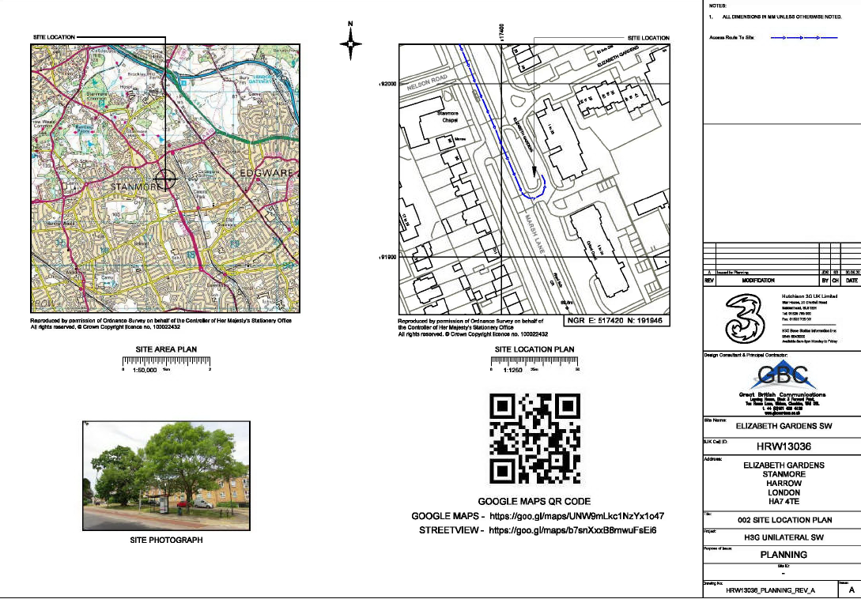

APPENDIX 3: SITE PHOTOS

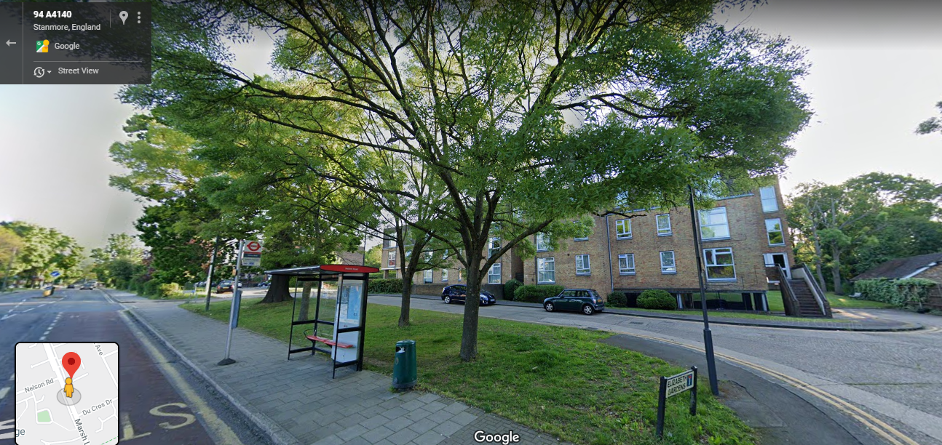

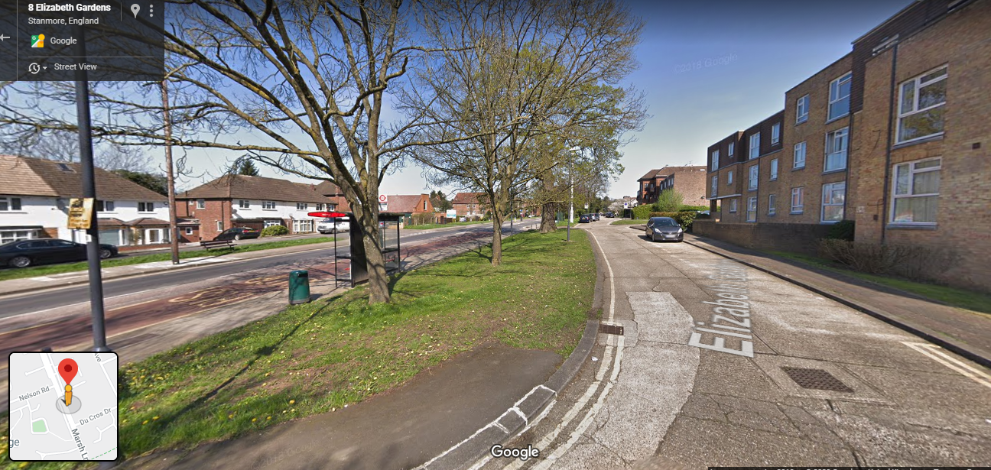
Street View Imagery Application Site (Dated May 2019)
Street View Imagery Application Site (Dated April 2018)
APPENDIX 4: PLANS AND ELEVATIONS

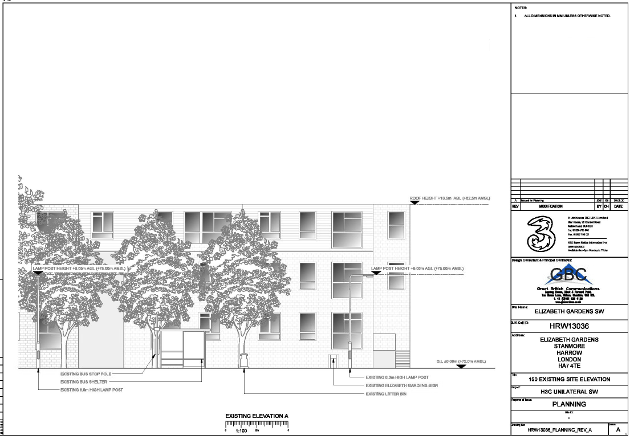

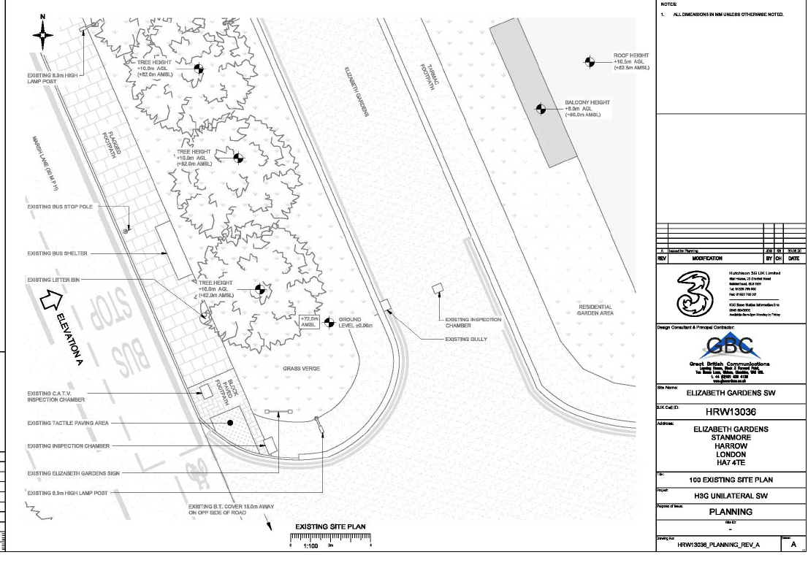

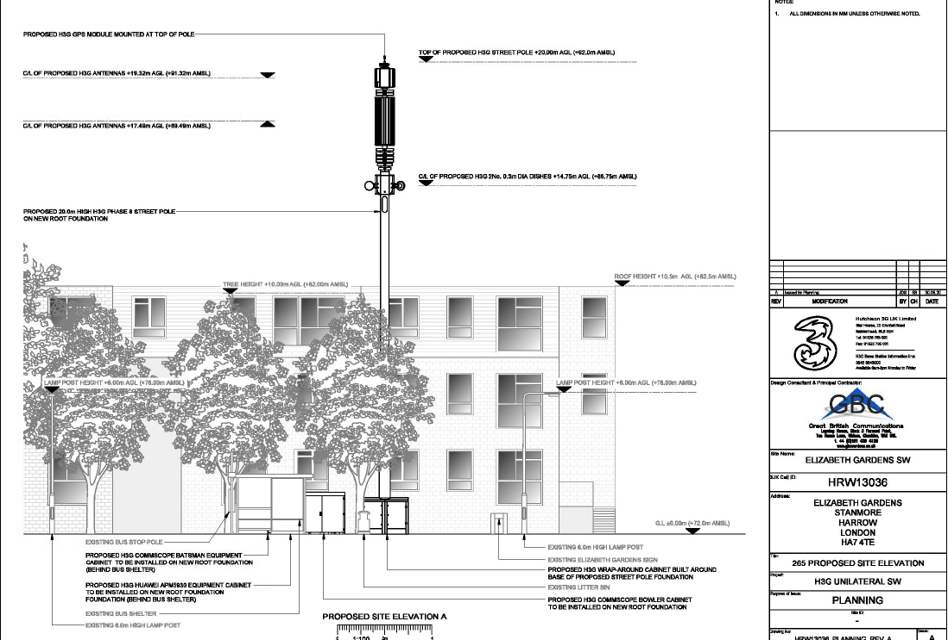

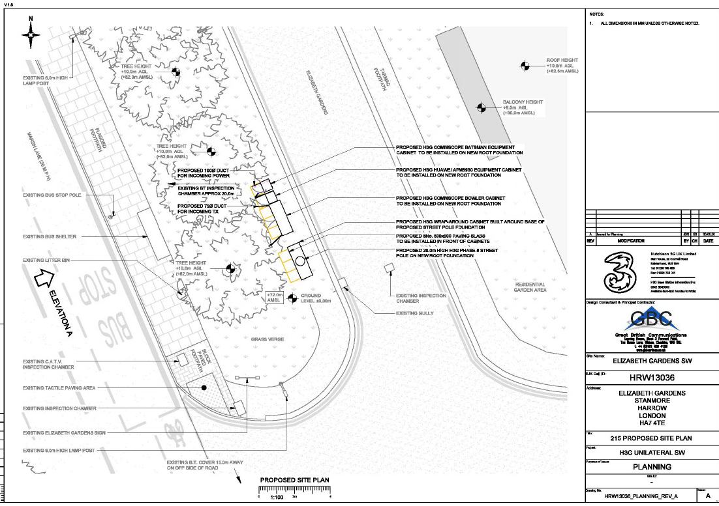
Appendix 5: Appeal Decisions
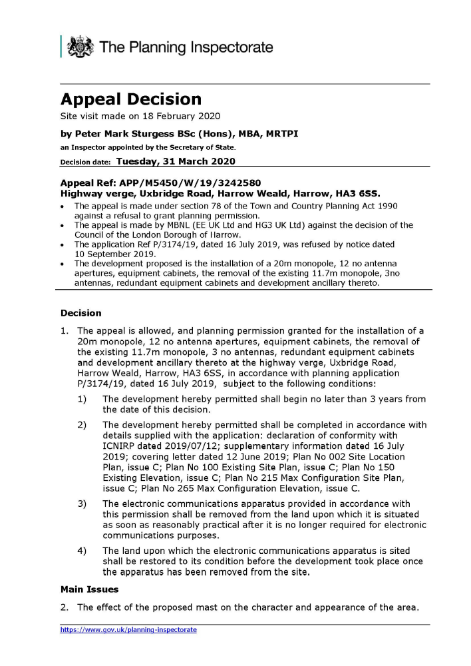
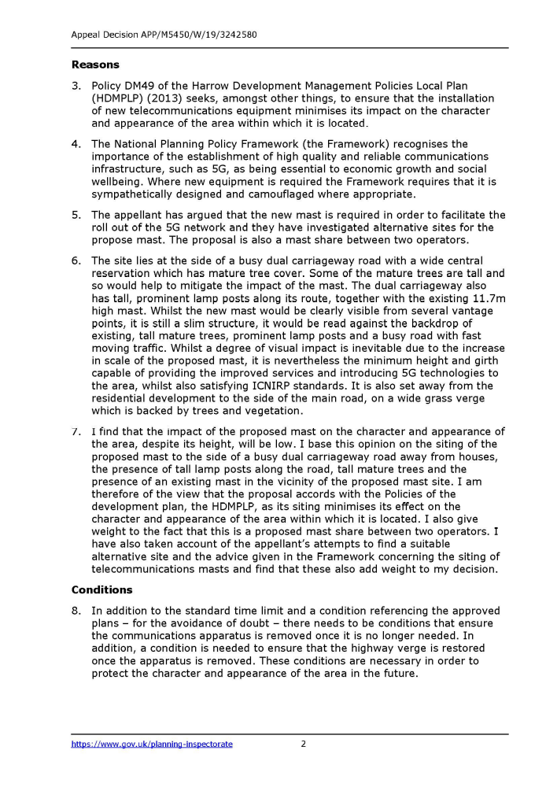

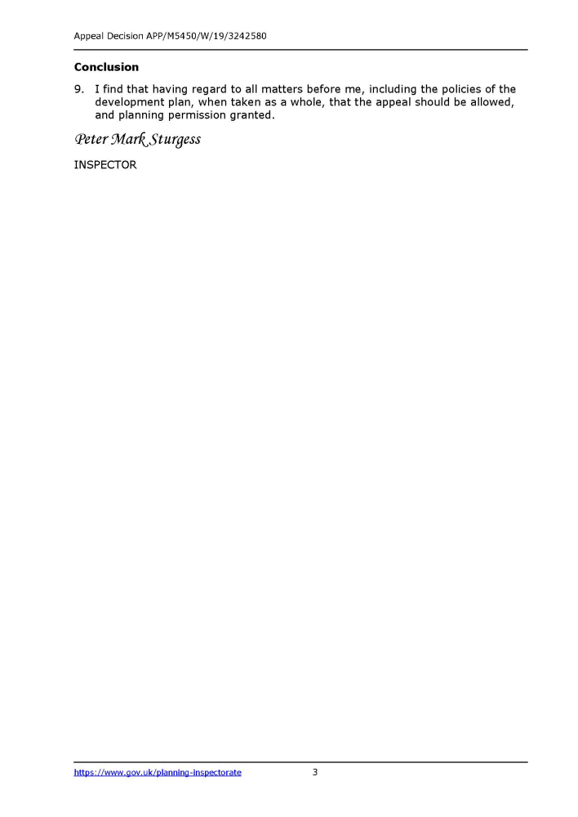

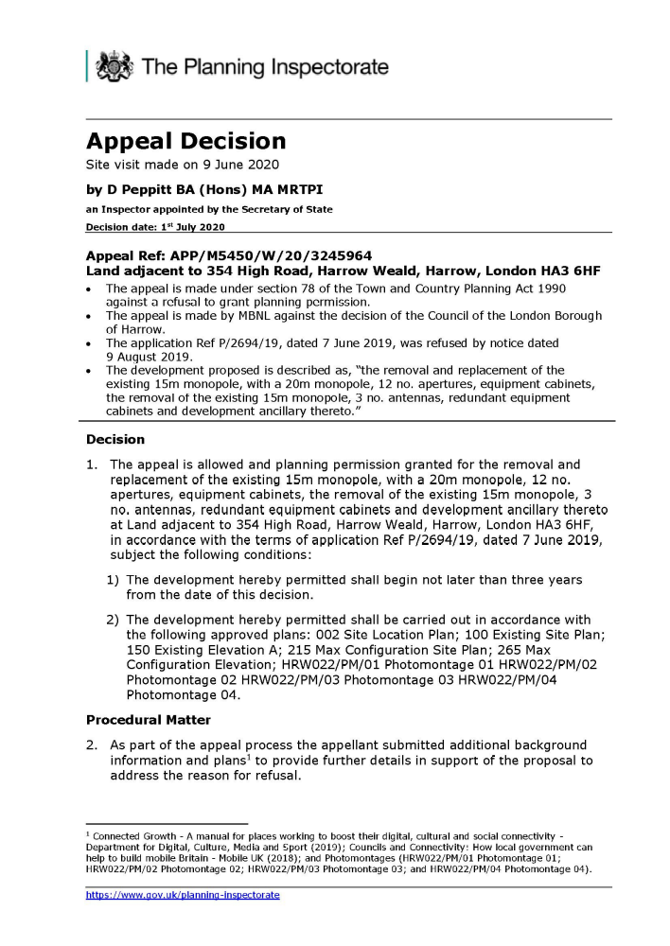

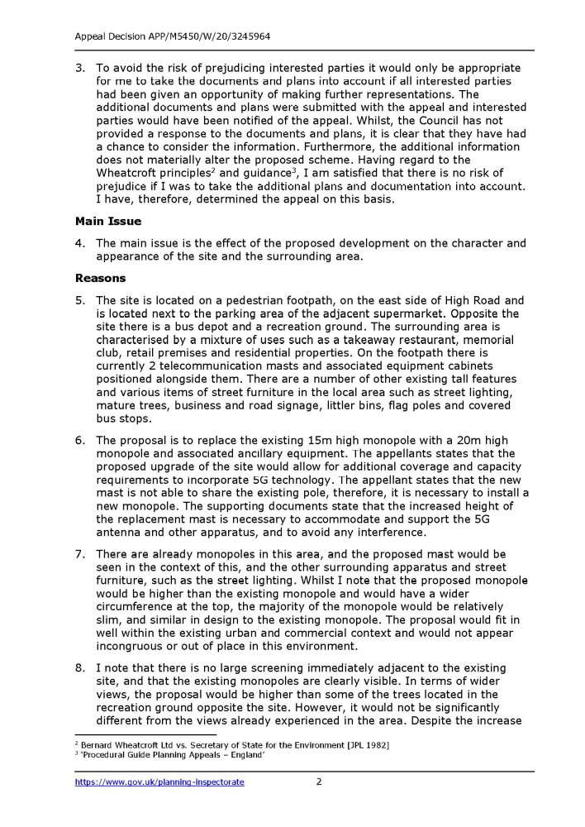

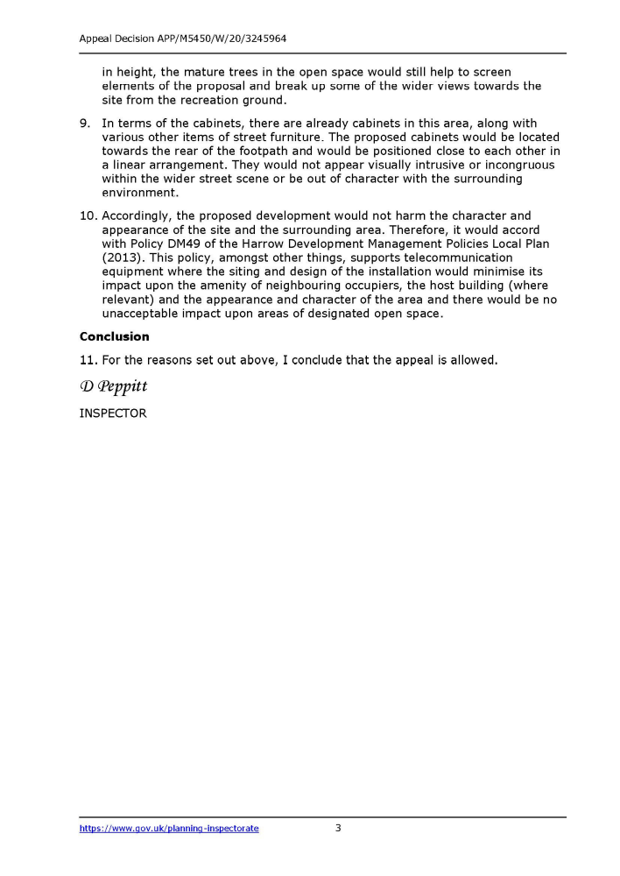

This page has been left intentionally blank

